WET or DRY?
Module 4 – The Senses
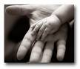
For this activity you are to touch a variety of fabrics while you are blindfolded. Using your sense of touch try to work out which samples are wet or dry. Tick the correct box.

SAMPLE | WET | DRY
Sandpaper
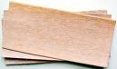
Tissue
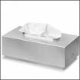
Sponge
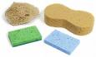
Wool
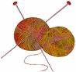
Ribbon

Leaf
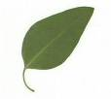
Felt
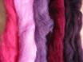

Piece of bread
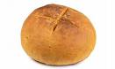
Piece of cotton fabric
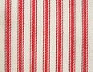

Were you correct ? What did you do to help you work out what samples were wet or dry?

___________________________________________________________________________

___________________________________________________________________________

